**Matlab Code For City Block Distance:**

% Parameters

radius = 10; % Radius of the circle

center = [0, 0]; % Center of the circle (x, y)

gridSize = 20; % Grid size (for visualization)

% Create a grid of points

[x, y] = meshgrid(-gridSize:gridSize, -gridSize:gridSize);

% Calculate the city block (Manhattan) distance of each point from the center

distances = abs(x - center(1)) + abs(y - center(2));

% Create a mask for points that lie on the "circle" boundary

circleMask = distances == radius;

% Plot the city block "circle"

figure;

hold on;

imagesc(-gridSize:gridSize, -gridSize:gridSize, circleMask); % Display the circle mask

colormap(gray);

axis equal;

title('City Block Distance Circle');

xlabel('X');

ylabel('Y');

hold off;

imshow;

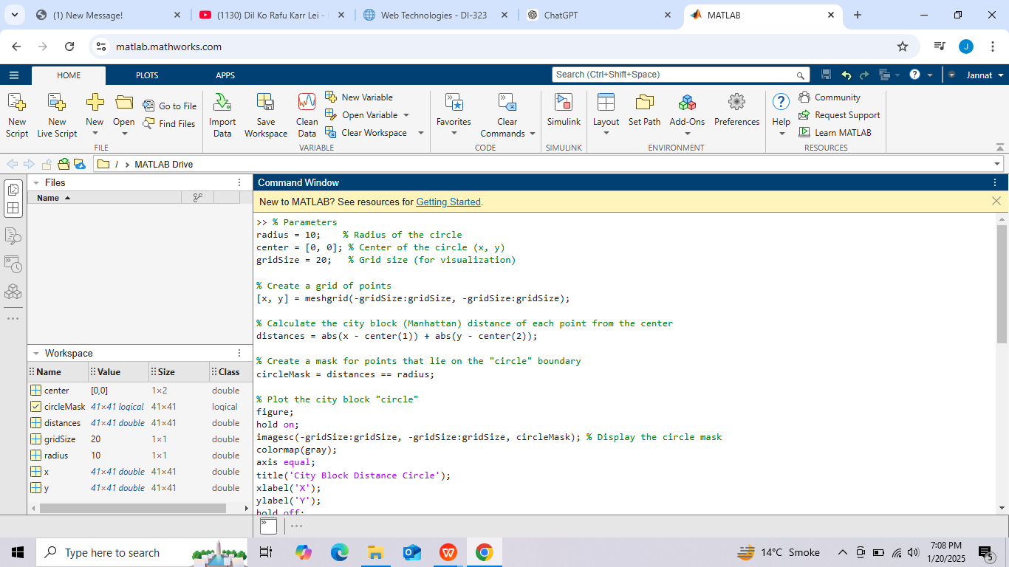



### Explanation:

* **City Block Distance**:

The Manhattan distance is calculated as ∣x−x0∣+∣y−y0∣|x - x_0| + |y - y_0|∣x−x0​∣+∣y−y0​∣, where (x0,y0)(x_0, y_0)(x0​,y0​) is the circle's center.

* **Boundary Mask**:

The points where the distance equals the specified radius form the boundary of the "circle."

* **Visualization**:

The resulting shape is a diamond, as the city block distance creates straight-line boundaries rather than a true Euclidean circle.

This code effectively demonstrates the concept of a circle in terms of city block distance.